**String handling in java**

**1. What is String ?**

**String is basically a sequence of characters**.

**In java, the string is an object and it is in the java.lang package.**

**2. Feature of String class:**

**a) It is an immutable class**

b) It is a final class. So can’t be inherited.  
c) String class implements Serializable, Comparable and CharSequence interfaces and extends Object class.

**3. How to create a String object ?**

There are two ways to create a String object.

**a) Using string literal.**

Ex:- String str = “abc”;

**b) Using new operator.**

Ex:- String str = new String(“abc”);

**a) String literal :**

String literal is basically created by assigning the value to a string variable with in double quote. i.e

String str = “abc”;

Now we create one more string object using string literal. i.e

String str1 =”abc”;

In this case, JVM will check the string literal pool or string constant pool for this object. If it exists in the pool then JVM won’t create a new instance, a reference to the pooled instance returns. Otherwise, JVM will create a new instance in the pool.

[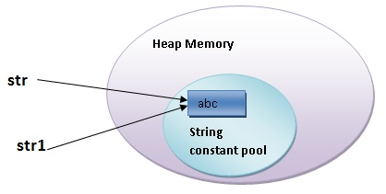](http://javacracker.com/wp-content/uploads/2012/12/StringPool_2.jpg)

So, only one instance will be created here and str.equals(str1) will return true. Because str and str1 both are pointing to the same memory location.

**b) new operator :**

String str = new String (“abc”);

In this case, JVM will create two object. One object is in the heap memory and another object is in the string constant pool.

[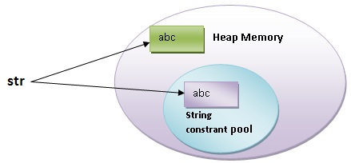](http://javacracker.com/wp-content/uploads/2012/12/StringPool_1.jpg)

**4. Some methods of the String class:**

I. **public int length()**  
II. public boolean empty()  
**III. public char charAt(int index)**  
IV. public String toString()  
V. public void getChars(int srcBegin, int srcEnd, char dst[], int dstBegin)  
VI. public boolean equals(Object anObject)  
VII. public boolean contentEquals(StringBuffer sb)  
VIII. public boolean equalsIgnoreCase(String anotherString)  
IX. public int compareTo(String anotherString)  
X. public boolean startsWith(String prefix, int toffset)  
XI. **public boolean startsWith(String prefix)  
XII. public boolean endsWith(String suffix)**  
XIII. public int hashCode()  
XIV. public int indexOf(int ch)  
XV. public int lastIndexOf(int ch)  
XVI. **public int indexOf(String str)**  
XVII. **public String substring(int beginIndex)**  
XVIII. public String substring(int beginIndex, int endIndex)  
XIX. public String[] split(String regex, int limit)  
XX. public boolean contains(CharSequence s)  
XXI. **public String concat(String str)**

[Core Java](http://javacracker.com/category/core-java/), [String Handling](http://javacracker.com/category/core-java/string-handling/)